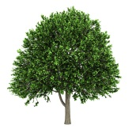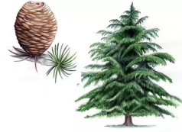

Summer Term

We hope you had a fantastic Easter break and are refreshed and ready for the summer term! This letter gives an overview of the teaching and learning that we will be covering this term along with key information and a few reminders.

Learning in the Summer term



Our first topic for the summer term is ***‘Under the Sea’*** based on the book ‘Somebody Swallowed Stanley by Sarah Roberts. Following this, our topic will be ***‘On our Doorstep*** with activities based upon the story ‘Goldilocks and Just the One Bear’ by Leigh Hodgkinson. Work in all subject areas will be linked to these topics wherever possible to make learning more enjoyable and meaningful for the children.

A topic web listing details of learning in each curriculum area is attached to the website. Should you require any further information, please do not hesitate to ask.

Reading

The children are continuing to read three times per week with adults in school and will be working on their fluency, prosody and comprehension skills. Little Wandle reading books will continue to be sent home on Fridays and must be returned on Mondays for other children to use. Your child will also bring a sharing book home each week; please return these to school on Thursdays.

If your child is in Year 2 and is no longer reading Little Wandle books, they can return their reading book on a **Friday** each week.

At home, please read with your child and read to your child as often as possible; it really does make a huge difference in many ways.

Homework

Each week your child will be given mathematics and English homework. Homework will be given out on Fridays and should be returned on Tuesdays. These tasks will be linked to the activities that the children have completed in class. Maths homework will continue to be set on MathShed and English tasks will be sent out in book bags on a Friday- please stick English sheets into your child’s homework book as we do not have time to do this for everyone. In addition to this, we will list ‘Weekly Spellings’ on our Year 1 and Year 2 page of the school website. *Please be aware that maths homework that is completed after the Tuesday 18:00 deadline, remains accessible to the children but shows as not completed when checked by the classroom teacher.*

Times Tables

This term Year 2 children should be confident in their 2, 5 and 10 times tables in accordance with the National Curriculum, including the corresponding divisions.

Please practise these regularly with your child at home using *Hit the Button, Coconut Multiples, Daily 10, Maths Fishing* or any other online games or Apps.

PE

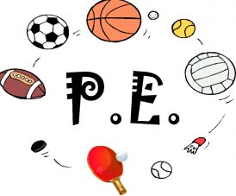Please ensure that your child wears the correct uniform for PE.

If your child has hair that is longer than their shoulders, please tie this back on PE days. Children should also have any earrings removed for health and safety reasons.

Please do not send laced trainers into school unless your child can tie these quickly and independently.

Asthma

If your child has asthma and needs an inhaler, please make sure that one is sent into school and that it can remain with us. A medical letter will need to be completed - these are available from the school office.

Naming clothes/belongings

**Please, please, please** make sure that all clothes/belongings are clearly named, especially sweatshirts, cardigans, coats and water bottles.

School Bags

Owing to limited storage space within the classroom and cloakroom areas, please may we ask that children bring a book bag to school. Apologies, but we do not have space for rucksacks and satchels. Children are to have **only one keyring** on their book bag as they do not fit in trays with more.

Water Bottles

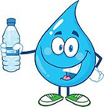

Please ensure that your child brings a filled water bottle into school each day. These are available to the children during class time. At the end of each day, water bottles will be sent home for cleaning and refilling. Sending in a bottle is especially important as the weather warms up. Please do not spend money on the expensive *air up* bottles – these can be very distracting in class and are very costly to replace.

Fun in the Sun

As sunnier days approach, please remember that your child will need to wear sun cream which should be applied in the morning at home. It is also a good idea to send a sun hat and sunglasses into school. As always, please ensure everything is labelled!

Home Time Arrangements

Please let us know, via an email or a call to the school office, if your child is going to be collected from school by somebody different than usual. Please do this as early as possible during the school day.

Thank you for taking the time to read this letter. If you have any questions or concerns, please do not hesitate to speak to us.

[beech@huntington.cheshire.sch.uk](mailto:beech@huntington.cheshire.sch.uk)

elm@huntington.cheshire.sch.uk

[maple@huntington.cheshire.sch.uk](mailto:maple@huntington.cheshire.sch.uk)

Kind regards,

Miss Bate, Mrs Gait, Mrs Jones, Mrs Pelham, Mrs Thomson and Mrs Ward (Class Teachers)