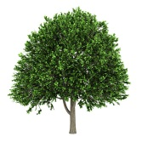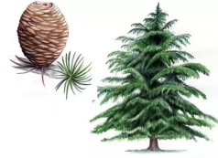

Happy New Year!

We hope that you all had an enjoyable Christmas break and would like to thank you for your very generous well wishes, cards and gifts.

This letter gives an overview of the teaching and learning that we will be covering this term along with a few reminders.

Learning in the Spring Term

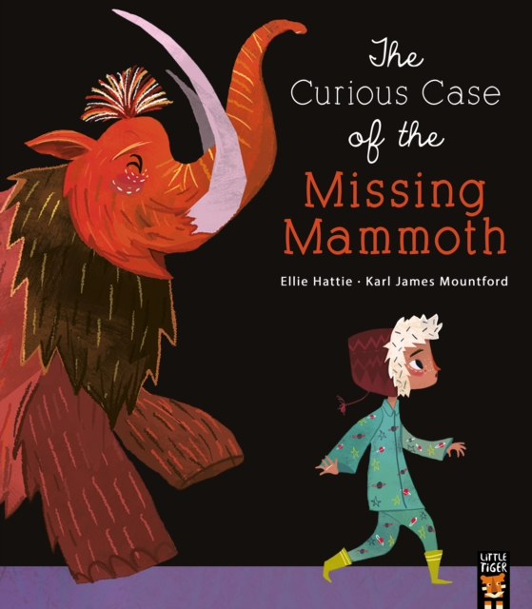Each half term, teaching and learning will be centred around a new topic. As a school, we follow the 'Pathways to Write' English scheme, where teaching is linked to a class text each half term. Our first topic for the spring term is ***‘Roar!’***  based on the book 'The Lion Inside by Rachel Bright. Following this, our topic will be ***‘Lost Worlds’*** with activities linked to the text ‘The Curious Case of the Missing mammoth’ by Ellie Hattie. Work in all subject areas will be linked to these topics wherever possible to make learning more enjoyable and meaningful for the children.

A topic web listing details of learning in each curriculum area is also available as a file to download on our Year 1 and Year 2 page of the school website. Should you require any further information, please do not hesitate to ask.

Reading

The children are continuing to read each week with adults in school and will be working on their fluency, prosody and comprehension skills. Reading books will continue to be sent home on Fridays and must be returned on Mondays for other children to use. Your child will also bring a *reading for pleasure* book home each Friday; please return these to school on Thursdays.

At home, please read with your child and read to your child as often as possible; it really does make a huge difference in many ways.

Homework

Each week your child will continue to be given mathematics and English homework. Homework will be given out on Fridays and should be returned on Tuesdays. These tasks will be linked to the activities that the children have completed in class. Mathematics homework will be set online using MathShed for the first half term and will then be sent home in your child’s Family Maths Scrapbook, created by National Numeracy for each year group, in the second half term. ***Please Note:******Mathematics homework that is completed online after Tuesday at 18:00 will show as not completed******to the teacher - so please encourage your child to do this on time.*** English tasks will be sent out in book bags on a Friday which will continue to include weekly handwriting. In addition to this, we will list weekly spellings and phonics on our Year 1 and Year 2 webpage for additional practice at home.

We are aware that everyone is very busy and understand that, on occasion, it may be difficult for your child to complete their homework on time. However, the additional practice that homework provides for your child really does help them to progress and builds confidence. We also want your child to establish a positive homework routine to help them in the future.

Times Tables (Year 2 only)

This term the Year 2 children will begin to learn the facts for the 2, 5 and 10 times tables in accordance with the National Curriculum.



Please practice these regularly with your child at home using *Hit the Button, Coconut Multiples, Daily 10, Maths Fishing* or any other online games or Apps. Later in the term, Year 2 children will also be given a login to Times Table Rock Stars. You may already be aware that your child will undertake a statutory assessment of their multiplication skills in Year 4 and it’s never too early to start practising!

PE

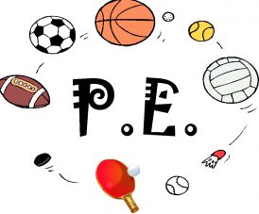To maximise the time available for PE, children should come to school on PE days wearing their PE kit, beneath plain, dark tracksuit trousers and a school sweatshirt, cardigan or full zip fleece.

PE kit is a plain white t-shirt, plain black shorts and plain black pumps or trainers. ***Please do not send your child into school wearing laced trainers unless your child can tie these quickly and independently.***

Elm Class's PE days are: Mondays and Wednesdays

Maple Class's PE days are: Tuesdays and Thursdays

Beech Class's PE days are: Tuesdays and Thursdays

If your child has hair that is longer than their shoulders, please tie this back on PE days. Children should also have any earrings removed at home for health and safety reasons.

Asthma

If your child has asthma and needs an inhaler, please make sure that one is sent into school and that it is able to remain with us. A medical letter will need to be completed - these are available from the school office.

Naming clothes/belongings

**Please, please, please** make sure that all clothes/belongings are clearly named, especially sweatshirts, cardigans, coats and water bottles.

School Bags

Owing to limited storage space within the classroom and cloakroom areas, please may we ask that children bring a book bag to school. Apologies, but we do not have space for rucksacks and satchels. Children are to have only one keyring on their book bag as they do not fit in trays with more.

Water Bottles

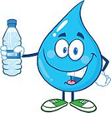

Please ensure that your child brings a filled water bottle into school each day. These are available to the children during class time. At the end of each day water bottles will be sent home for cleaning and refilling.

Home Time Arrangements

Please let us know as early as possible in the school day if your child is going to be collected from school by somebody different than usual. Please speak to the class teacher in the morning or email/call the school office. Please do not use the class email address for this purpose as sometimes teachers do not have time to check this during the day.

Please ensure that your child is closely supervised on the playground at the start and end of the day. Children are not allowed to use the adventure play equipment, to use balls or to ride bikes or scooters on the yard during these times.

Thank you for taking the time to read this letter. If you have any questions or concerns, please contact us via our class email address in the first instance:

[maple@huntington.cheshire.sch.uk](mailto:maple@huntington.cheshire.sch.uk)

elm@huntington.cheshire.sch.uk

[beech@huntington.cheshire.sch.uk](mailto:beech@huntington.cheshire.sch.uk)

Kind regards,

Miss Bate, Mrs Gait, Mrs Jones, Mrs Pelham, Mrs Thomson and Mrs Ward (class teachers)