**Religious Education**

* What does it mean to belong?

**English**

* Daily Little Wandle phonics
* Daily handwriting
* Group/individual reading three times per week
* Weekly spellings

**Please see our webpage for end of half term expectations for Year 1 and Year 2 for writing**

[Huntington Community Primary School: Autumn Term 2024](https://www.huntington.cheshire.sch.uk/page/autumn-term-2024/151392)

**Mathematics**

* Place value
* Addition and subtraction
* Shape

**Please see our webpage for more details about learning within each of these areas of mathematics for Year 1 and Year 2**

[Huntington Community Primary School: Autumn Term 2024](https://www.huntington.cheshire.sch.uk/page/autumn-term-2024/151392)

**Autumn 1: Let’s be Friends!**

**Autumn 2: What’s in the toy box?**

**Physical Education**

* Dance
* Fitness and basic skills
* Ball skills

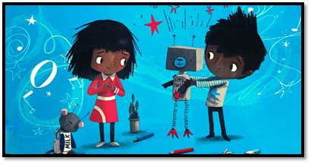

**Design and Technology**

* Templates and Joining Techniques (Puppet Making)

**Computing (taught by Mrs Williams)**

* Online safety
* Digital painting
* Technology around us

**Art and Design**

* Drawing and painting

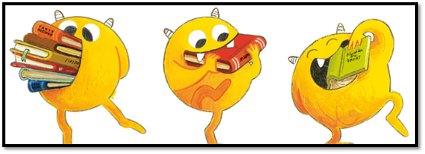

**History/Geography**

* Hot and cold places
* Toys through time

**Science**

* Material World

**Please see our webpage for more details about learning within this subject**

[Huntington Community Primary School: Autumn Term 2024](https://www.huntington.cheshire.sch.uk/page/autumn-term-2024/151392)

**PSHE**

* My Happy Mind
* Being Me in My World  
  'Who am I and how do I fit?'
* Celebrating Difference

**Music**

* Active listening (movement), beat, echo singing, showing pitch moving
* Learning and performing songs for our Christmas show