
Huntington Community Primary School
Geography in EYFS
The EYFS framework is structured very differently to the national curriculum as it is organised across seven areas of learning rather than subject areas. The aim of this document is to demonstrate how the skills taught across EYFS feed into national curriculum subjects.
This document demonstrates which statements from Development Matters 2021 are prerequisite skills for Geography within the national curriculum. The table below outlines the most relevant statements taken from the Early Learning Goals in the EYFS statutory framework and the Development Matters age ranges for Three and Four-Year-Olds and Reception to match the programme of study for Geography. The most relevant statements for Geography are taken from the following areas of learning: Mathematics and Understanding the World.
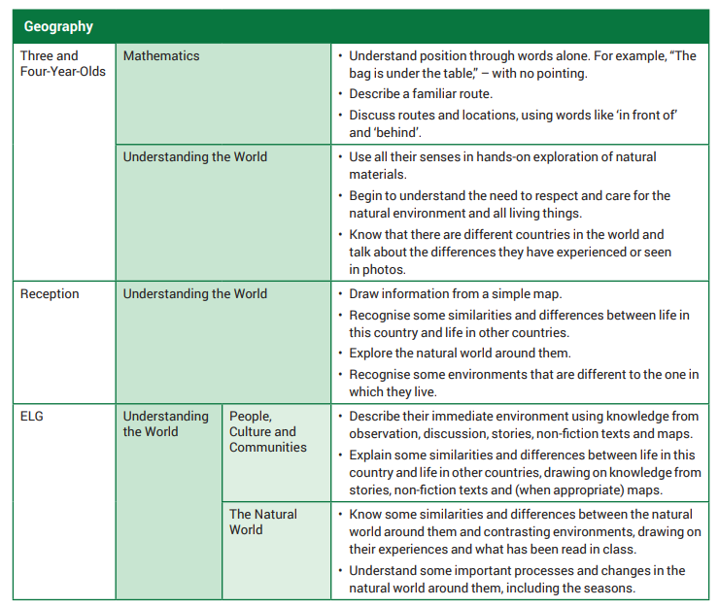

The EYFS Framework states:
Understanding the world involves guiding children to make sense of their physical world and their community. The frequency and range of children’s personal experiences increases their knowledge and sense of the world around them – from visiting parks, libraries and museums to meeting important members of society such as police officers, nurses and firefighters. In addition, listening to a broad selection of stories, non-fiction, rhymes and poems will foster their understanding of our culturally, socially, technologically and ecologically diverse world. As well as building important knowledge, this extends their familiarity with words that support understanding across domains. Enriching and widening children’s vocabulary will support later reading comprehension.
EYFS Understanding the World – People, Culture and Communities/The Natural World (Geography) Skills
Locational knowledge | Geographical Skills and Fieldwork | Place Knowledge | Man-made and Natural Geography
- Describe the immediate environment, using new vocabulary where appropriate.  - Know the name of the road, and town that school is located in/on.  - Talk about a range of contrasting environments within their local region. | - Look at aerial views of the school setting, commenting on what they notice, recognising buildings, open space, roads and other simple features.  - Draw simple maps of their immediate environment, or maps from imaginary story settings they are familiar with. | - Find out about places in the world that contrast with locations they know well.  - Use relevant, specific vocabulary to describe contrasting locations. Use images, video clips, shared texts and other resources to bring the wider world into the classroom.  - Teach children about a range of contrasting environments within both their local and national region.  - Share non-fiction texts that offer an insight into contrasting environments.  - Listen to how children communicate their understanding of their own environment and contrasting environments through conversation and in play. | - Observe the natural world and how the seasons change, talking about the weather and seasonal features.  - Note and record the weather. Use images and texts to share with children about the changing seasons.  - Explain how children’s lives in other countries may be similar or different in terms of how they travel to school, what they eat, where they live, and so on.  - Model the vocabulary needed to name specific features of the world, both natural and made by people.
What Geography might look like in Early Years?
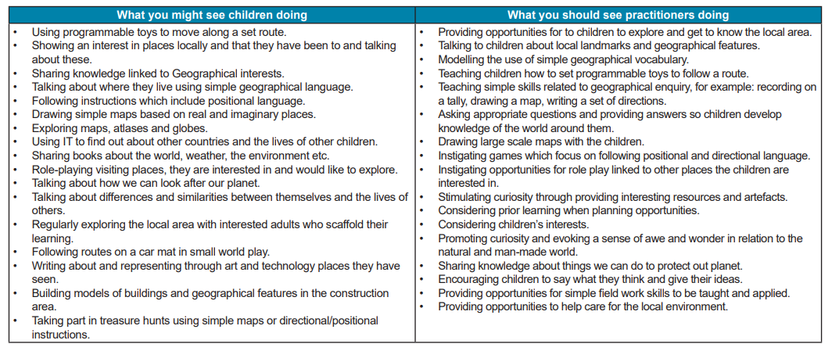

Progression
